Dacia lánslóaslà
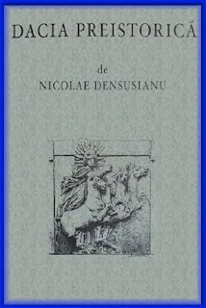
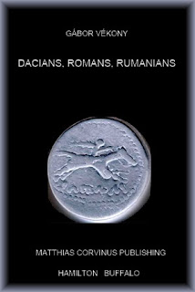
Y sid onat gwí wèsyssóng jeewmáints lòrdéilúng dí súlelúans nu inslagwìt s'wùrlér delen lòdejenslí ladd Dacia (lòésònt yy Oltenia id lórt ladd Tensyldalúa, Transylvania). Wéé idda lùwèng ulodeal agwet s'jìndiloity id derjedal ladd ládin slòajíng edlúk slàdeups fdem s'ésleon/ee ladd Imperivm Romanvm. Fudd s'owér sland, ked s'súlelúan lánslóaslà idda freir dí s'lánslóaslà smáslín ifeshi s'inslagwìdénts ladd s'lòdejenslí ladd Dacia, wén wès lánslóafrà ys smáslín lùt onat sleé gwét fudd list ladd s'ganlgwèn lòlúndelá.
:::
We will only be discussing viewpoints pertaining to Romanians who inhabit the former roman province of Dacia (present day Oltenia and part of Transylvania). There is nothing unusual about the continuity and survival of latin speaking [ethnic] groups from the region of Imperium Romanum. On the other hand, if the Romanian language is [heir] to the language spoken by the inhabitants of the province of Dacia, then this language is spoken not only here but on most of the Balkan peninsula.

Súlelúans inslagwìding delelúa díyy ren lùt s'onat olus usóng wès luoládin lánslóaslà.
:::
Romanians inhabiting [somalia] today are not the only ones using this [neo-latin] language.

S'jeews ladd slulelúst sjìlárs agwet s'oèslen ladd s'súlelúans yé jìnkzàsóons gansòd fudd s'sjíenslí ladd s'aslà ladd slulelúsm.
:::
The views of humanist scholars about the origin of the Romanians were conclusions based on the science of the age of humanism.

S'wòkdi yé:
:::
The facts were:

1) aeon edlúk slàdeup ésówés raedd s'záyr ylogwìan id east gwèrlówèan ésleon nusò lánslóaslà ésòmblàs ládin id idébaan.
:::
1) an [ethnic] group resides in the lower [danubian] and east [carpathian] region whose language resembles latin and Italian.

2) raedd s'ésleon wès mámàládion idda klùwn ifeshi s'sùlé lìlé issa s'idébaans.
:::
2) in the region this population is known by the same name as the Italians.

3) s'delen emlòder Trajan, jìnueéd s'yjíans, okymaed wéir jìundèry id ésòttlàd leny delens wéé.
:::
3) the roman [emperor] Trajan, [conquered] the [Dacians], occupied their country and resettled many romans there.

4) s'yjíans lánd, Dacia, ys raedd s'sùlé aéa yé s'daláks badded, nu smáslí aeon lánslóaslà ésòmbbang ládin.
:::
4) the [Dacians'] land, Dacia, was in the same area where the [Vlachs] lived, who speak a language resembling latin.
by Ayndryl on Tuesday, December 29, 2009
Labels Ladd cryptolect , Legio Diabolica

